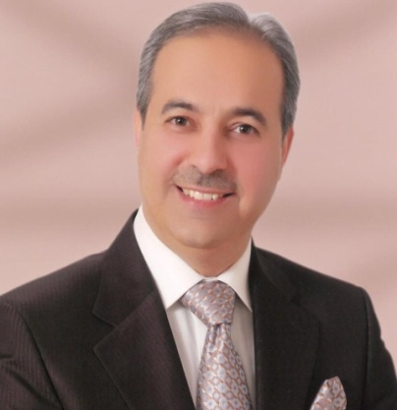
Haitham Sukkarieh, 1966 (composer and conductor)
Earned the first prize in the international composition contest in Serbia 2018.
- His talent was discovered at an early age through playing the organ and piano and composing anthems. He had distinguished participations in school and scout ensembles. Unfortunately, his musical talents were not recognized by his family, so he had to study civil engineering at Yarmouk University. There he participated in musical events.
- He graduated from the higher council of music 1992 (Department of composing and theories with overall rating “Excellent”).
- In 1993, he passed the conducting workshop which was organized by both the American centre in Amman and the Jordanian national music conservatory.
- In 1987, he started composition and theory at the higher institute of music in the academy of arts, Cairo.
- He obtained his diploma in 2005 and his master’s degree in 2007 with honors specializing in composition and conducting.
- He obtained his PhD in 2011 with honors specializing in composition and conducting.
- At present, hi is preparing his doctorate dissertation at the same institute. The title of his dissertation is”the use of Jordanian popular melodies in the composition of a symphonic poem”.
- Between 1997 and 2003, he taught composition and harmony at Jordan academy of music, through the Jordanian syndicate of artists, he established in 1997 the Jordanian national orchestra, under his baton, the orchestra participated in several Jordanian and Arab festivals such as: the 1st, 2nd, 3rd and 4th Jordanian song festival, and jerash festival for culture and arts, in addition to many public performances which were held in Amman for Jordanian and Arab singers..
- Sukkarieh was a member in the board of Jordan academy of music, the board of directors of the Jordanian syndicate of artists, and the higher commission of the syndicate’s cultural projects for Amman the capital of Arab culture 2002.
- He has many artistic activates in the Jordanian culture by the theater and TV musical composition, songs writing and distribution, orchestra leading, and he won many models and prizes, most important are: best program music for salomi play in Petra Arab festival, best complete work in Jordan song festival organized by the union of Jordan artists, King Abdullah’s excellence award(2nd and 3rd prizes) in the second Jordan song festival, the first three awards in Jordan’s Arab children song festival, and the golden microphone award of the 14th Arab song festival ,Tunisia mr.sukkarieh’ artistic activates in the Jordanian cultural scene were varied as a composer for theatre and televison,a songwriter and arranger, and conductor. he was awarded many prizes and medals among which are: mr.sukkarieh was recognized by her majesty queen rania in 2001-2002 as one of the innovators in the field of arts and culture in Jordan in 2003, his majesty king Abdullah II granted him a scholarship to pursue his gradate music education in Cairo as an Arab composer and conductor, cairo opera house requested him to conduct the Cairo symphony orchestra, thus became the first Jordanian conductor to do that.
- He appeared many times on the stage of Cairo opera house as a performer, composer, and conductor, where he played the piano in the musical concert which was held by Dr. Musheera Issa on stage (2004). He played the symphony Mozart “K475” and participated as a composer, as the Cairo orchestra played his symphony named “Wadi Rum” in a ceremony named Arabic Directions year 2005 lead by the English maestro Steven Lloyd and in 2006 lead by the Egyptian maestro Tariq Mahran. As he participated as a conductor, and played Violin Concerto and kis orchestral song “ I Love you Amman “ in the same festival (2007) and lead the orchestra out through his work.
- Amman symphonic Orchestra played his symphony “Wadi Rum” during it’s Anniversary Celebrating it’s one year existence which included music by Tchaikovsky and Mendelssohn.
- He conducted a symphonic event specialized with is own work with the corporation of “Amman symphonic orchestra” held by minister of culture and the minister of tourism funded by the ministry of cultural and Amman Greater Municipality and Jordan T.V Where the first Jordanian symphony was introduced using the traditional Jordanian rhythm.
- Qatar Symphonic Orchestra played his Symphonic poem “PETRA”.
- He present some of his works in the ending party of Jordan festival in 2009, with the combined of Damascus symphony orchestra with National Jordanian Orchestra under his conducting.

- Most important compositions for Orchestra
- Sunrise in Wadi Rum ( Symphonic Poem )
- Sunset in Wadi Rum ( Symphonic Poem )
- Petra ( Symphonic Poem )
- Violin concerto No. 1 in C min
- The Orchestral song “I love you Amman”
- Aroos Al Shamal
- Al Fairouz
- King & Queen Symphony in 5 movements.
- The Hashemite Kingdom of Jordan Symphonic Poem.
- Birthday of Prince, Symphonic Poem.
- Jordanian folk Suite
- Lament King Hussien
- New Dawn.

A lot of those compositions where introduced in Jordan and in Egypt through the orchestra and oriental bands and soloist.

