The University of Jordan
Introduction to Programming
Assignment 6

Write a program that asks the user to prompt an Integer number and then test whether it is Palindrome Numbers or not.
The following are Palindrome numbers:
- 22
- 333
- 67876
- 44444
- 123454321
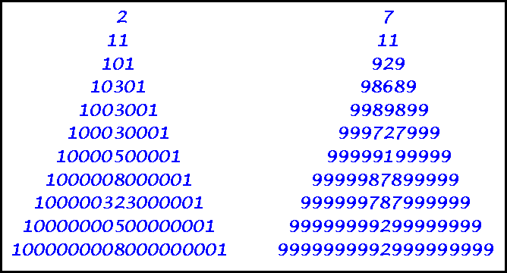

A palindrome is a word, phrase, number, or other sequence of symbols or elements, whose meaning may be interpreted the same way in either forward or reverse direction.

