CURRICULUM VITAE

Prof. Dr. Mohammad Harb
Department of Animal Production
Faculty of Agriculture
University of Jordan
Amman - Jordan
DATE OF BIRTH: 1944 PROFESSION: Ruminant Nutritionist
Nationality: Jordanian PROPOSED POSITION: Livestock Expert
Fax: 962-6-535-5577 Work Phone: 962-6-535-5000/Ext. 2567
E-mail: MUHarb@JU.Edu.JO Home Phone: 962-6-534-1475

ACADEMIC QUALIFICATIONS:

- B.Sc. Nutrition.(American University of Beirut, Lebanon), 1969.
- M.Sc. Animal Nutrition, (A.U.B.), 1971.
Thesis: Citrus Pulp as a Source of Energy for Ruminants.
- Ph.D. Ruminant Nutrition, (University of London (Wye College), 1980).
Thesis :Variations between Dairy Cows in Voluntary Feed Intake.

KEY QUALIFICATIONS:

Dr. Harb is an expert in livestock, he has a wide experience in this field and has conducted a lot of studies covering this field. His experience covers sheep nutrition, management, and production. He also was the head of the team in Ministry of Agriculture for Evaluation of red meat and milk production in Jordan as well as carrying the feasibility study for improved sheep production in Jordan. He was the head of the department of Animal Science in Jordan University (Amman) and the head of Nutrition and Animal Science in in Jordan University of Science and Technology (J.U.S.T;) (Irbid) and Acting Dean for the Agricultural Department for a partial time in (J.U.S.T;)

EXPERIENCE:

1980 - Today: | Faculty of Agriculture - University of Jordan.
1996: | Professor.
1996: | Acting Dean (J U.S.T).Head of Department of Nutrition and Animal Science.
1992 -1994: | Head of Animal Production Department - University of Jordan.
1986: | Associate Professor
1977 - 1980: | Studying for Ph.D. in London University.
1975 - 1977: | Lecturer - University of Jordan.
1972 - 1975: | Head of Nutrition Department , King Hussein Medical Center.
1971 - 1972: | Poultry production in the private sector.
1969 - 1971: | Research Assistant in the American University of Beirut(A.U.B).

Teaching Experience:

Feeds and Feeding; Feed Analysis; Sheep Production; Range Management; Beef Production; Ruminant Nutrition; Advanced Ruminant Nutrition; Seminar 391; Seminar 491; Practical Application in Animal Production and Research in Animal Production.

Scientific Symposiums and Workshops:

- The first scientific meeting of the General Federation of the Arab Veterinarians. Amman - Sept. 7-10/1981.
- Sheep Improvement in Jordan, Amman, Oct. 25-27/1982.
- Annual Meeting of the British Society of Animal Production. Harrogate. Oct. 29-31/1983.
- Evaluation of the Local and Foreign Breeds of Cows in Arab Countries. Organized by Arab Organization for Agricultural Development, (A.O.A.D.) Amman July 27-30/1983.
- The use of Unconventional Stuffs as Feeds for Ruminants, Nov. 20-24,- Amman.
- Expert Consultation for Small Ruminants in the Near East (FAO), Oct. 23-27/1984 - Tunis.
- Systems of Ruminants Production in Arab Countries. (A.O.A.D.), Nov. 10-14/1984 - Riyadh.
- Goat Production in Jordan. (GTZ.) March 25 - April 3/1989 - Amman.
- Extension Training, University of Jordan, Sept. 9-13. 1990. Amman
- Cereal, forges and Sheep Production Workshop, May 6-8/1990 - Amman.
- Increasing Red Meat Production by New Technologies, Sept. 9-15/1991 - Amman.
- Management and Feeding of Sheep, ICARDA, Oct. 26 - Nov. 4/1991 – Amman.
- Religious conference about feeds and animal products. For of Zerka, University July 25-27 - 1998 .
- National second scientific conference. Agr. Association. October 10- 2000.
- Feed formulation and ingredients purchasing planning methods. Training course in Amman-Jordan Feb. 9-11-2002. American Soybean Association- United Soybean Association. Amman-Jordan
- Full Fat Soya. American Soybean Association. Amman-Jordan, May 7-9 2002.
- Dairy feeds. American Soybean Association. Amman-Jordan. May 7-9-2002.

Consultation:

- Head of a team-Ministry of Agriculture. “Evaluation of Red Meat and Milk Production in Jordan”.
- Head of a team - Pension Fund for Sabha and Subhia Project.
- “A Feasibility Study for Improved Sheep Production Project in Jordan”.
- Chief Editor of “Al-Muhandis AL-Zerai”: 1986 - 1988.
- Member in Economic Consultation Council-Agricultural Committee-
- Animal Production Section (for the government).

Publications:

- Bhattacharya, A.N.; Harb, M. 1973. Sheep production on natural pasture by roaming Bedouins in Lebanon. Journal of Range Management. 26(4): 266 - 269.
- Bhattacharya, A.N.; Harb, M. 1973. Dried citrus pulp as a grain replacement for Awassi Lambs. Journal of Animal Science. 36(6): 1175 - 1179.
- Harb, M. Y: Campling, R.C. 1978. Variations between dairy cows in voluntary intake of silages. Fifth Silage Conference, Hannah Research Institute, West of Scotland & Agr. College (1978): 36 , 38.
- Faqih, A.M., Harb, M. & Dyer, I. A. 1979. Utilization of High Levels of Alkali- treated wheat straw for fattening Awassi lambs. Dirasat 6(2): 79 - 91.
- Harb, M. 1982. Extensive sheep production on natural pasture by roaming Bedouins in Jordan. First Veterinary Conference - Amman.
- Harb, M.; Shourafa, W. 1982. The use of poultry litter, olive pulp treated with NaOH, brewery grain and straw in economical ration in the fattening of Awassi lambs.
- The Arab Conference of the Utilization of Uncommon Materials as Animal Feed, ( AOAD). Nov. 20-24 (1982) Amman (Arabic).
- Harb, Y. M.; Campling, R.C. 1983. Effects of the amount of barley and time of access to grass silage on the voluntary intake eating behavior and production of dairy cows. Grass and Forage Science Vol. (38) : 115 - 119.
- Harb, M. 1983. Pilot project on goat raising in Jordan - A regional expert meeting on the role of women in production. The Ministry of Social Development / The Hashemite Kingdom of Jordan in cooperation with the Food and Agriculture Organization of the United Nations (FAO) Amman, Oct. 23-26/1983 (Arabic).
- Nahar, A.C.; Lubbadeh, W. and Harb, M. 1984- Important features of animal production in Hashemite Kingdom of Jordan Evaluation of local, mixed and foreign cows in Arab countries (AOAD), Khartoum (Arabic).
- Harb, M. 1984. Intensive rearing of Chios ewes under Jordanian Situation. Arab conference of Animal production Pattern for Ruminants in Arab countries. (A.O.A.D.) - Amman (Arabic).
- Harb, M. 1984. The economics and management problems of sheep fattening in Jordan. FAO/ Expert Consultation of Small Ruminant Research and Development in the Near East - Tunis, Tunisia, 25-27 Oct. 1984.
- Harb, M. 1984. The economics and management problems of sheep fattening in Jordan. FAO/ Expert Consultation of Small Ruminant Research and Development in the Near East - Tunis, Tunisia, 25-27 Oct. 1984.
- Harb, M., Campling, R.C. 1985. Variation among pregnant non lactating dairy cows in eating and ruminating behavior digestibility and voluntary intake of hay.
- Grass and Forage Science 40 : 109 - 111.
- Harb, M. Reynolds. V. and Campling. A.C. 1985. Eating behavior, social dominance and voluntary intake of silage in group-fed milking cattle. Grass and forage Science 40: 113 - 118.
- Harb, M., Fawal, M. and Goddard, G. 1986. The use of barley - legume mixtures for Fattening Awassi Lambs. Dirasat, Vol. 13 (8): 159 - 175.
- Harb, M. 1986. The use of olive pulp in the fattening of Awassi Lambs. Dirasat, Vol. 13: 37-53.
- Harb, M.; Shourafa. W. and Lubbadeh. W. 1986. The use of poultry litter and olive pulp treated with sodium hydroxide in the ration of Awassi male lambs. Dirasat 13 (2): 67-79.
- Harb, M. 1986. The use of tomato pomace in the ration of Awassi lambs. Dirasat 13: 67-79.
- Habbab. S. and Harb M. 1986. Economical analysis study for Awassi fattening in Jordan. Dirasat 13 (5): 73-95.
- Habbab, M. S. and Harb. M. 1989. Economics of lamb fattening in Jordan (analysis study) Dirasat 16 : 52-70.
- Harb, M. and El-Hattab. A.H. 1991. Forage yield and quality of Sorghum-Sudan grass hybrid as affected by planting dates and cutting heights at harvest in the central valley of Jordan Dirasat. Vol. 18b: 70-92.
- El-Hattab. A.H. and Harb, M. Y. 1991. Effect of planting dates and nitrogen levels on forage yield and quality in sorghum Sudan grass hybrid in the central valley of Jordan Dirasat. Vol. 18 (4): 7-25.
- Harb, M. 1992. Sheep production under extensive system. Jordan Pastural on Pasturalism” Share-Kord 1-6 Sept. Iran.
- Harb, M., and El-Hattab,A.1992. The effect of nitrogen fertilization and seeding rate on forage production and quality of Rhodes grass.Dirasat19(2):34- 55.
- Harb, M. Y. 1993. The use of cereal grains in intensively fattening Awassi lambs to high weights. Dirasat. 20B(3): 67- 76.
- El-Hattab, A.H. and Harb, M. Y. 1994. Forage yield and quality of Egyptian clover as affected by planting dates and seeding rates. Dirasat 21B: 62- 70.
- Harb, M., El-Hattab, A.H., 1994. Effect of fall and Spring planting dates and level of seeding on the quantity and quality of alfalfa. (Dirasat). 20B (3): 71-85.
- Harb,M.1994.The effect of sponges impregnated3 with progesterone and PMSG on the reproductive performance of Awassi ewes. Dirasat 21(3):117-125.
- Harb,M.1994.The comparison between immunization against androstenedione with sponges impregnated with progesterone and PMSG on the reproductive per on the reproductive performance of Awassi ewes .Dirasat 21B(3):117- 125.
- El-Shakret, K.; Harb , M.Y.; Abu-Zanat, M; and Tabba’a, M 1996. Effect of different feeding levels on the productive and reproductive performance of Awassi sheep in Jordan valley . Dirasat 23(2). 118-130.
- Dayeh, R. ; Tabba’a, M., Harb, M.Y. 1996. Effect of different feeding levels on the productive and reproductive performance of Shami (Damascus) goats in the Jordan valley . Dirasat 23(2). 131-142.
- Kalabani, j. and Harb, M.Y. 1996. Voluntary intake and digestibility of rations contained different levels of tomato pomace fed to pregnant and lactating ewes, Dirasat, 23(3). 177-187.
- Darwish, A. and Harb, 1996. Utilization of dried banana leaves as a roughage source in feeding Awassi sheep. Dirasat 23(3) 187-196.
- Muwalla, M.M. Harb, M.Y. and Crosby, T.F. 1998. Effects of Lasolacid and protein levels on the performance of Awassi lambs. Small Ruminant Research 28: 15-22 (English).
- Abdulla, A.Y. Muwalla, A.Y. 1999. Evaluation of protein sources for growing and finishing Awassi lambs. Turkish Journal of Veterinary and Animal Sciences 23: 475-482.
- Shaker, R.R. Muwalla, M.M. Harb M.Y. Abdulla, A.Y. and Crosby, T.F. 1999. Effect of rumen undegradable supplement on the growth rate and milk yield and composition in lactating Awassi sheep. Czech. J. Anim. Sci. 43: 275-279.
- Muwalla, M.M. Harb. M.Y. Abudulla, Y. 1999. Optimum use of straw based diet for suckled Awassi ewes. Zootech. 48: 389-395.

Books:

- Harb, M. and Kamel, M.K. 1984. Encyclopedia of Animal production . The Hashemite Kingdom of Jordan. ACSAD Damascus (Arabic).
- Harb, M. and Karablieh. I. 1990. Studying the reality, the marketing and the development of poultry production of . of Ministry of Agriculture - FAO-Amman.
- Harb, M. and Karablieh. I. 1990. Studying the reality, the marketing and the development of feed production of Jordan. Ministry of Agriculture - FAO- Amman..
- Nabulsi, H.; Harb, M. and Ababneh, M. 1993. Report of review and planning group for livestock subsector. Agricultural sector. Review and Policy
- Harb, M. . Sheep Production in the Near East Under Extensive System. Jordan Pastrol System - A Case Study - FAO . Rome (under publication).
- Nabulsi, H.; Harb, M. and Ababneh, : M. 1993. Report of review and planning group for integrated livestock subsector . Agricultural Sector Review and Policy Implementation Plan. Ministry of Agriculture- Amman.
- Hamadan, M., Harb, M., Karaki, M. Salman, 1996. Identification of Jordanian male and female Farmers’ Needs. GTZ- Ministry of Agriculture.
- Fataftah, A., Harb, M., Abu Zanat, M. , Salem, M. Asali, K. Hammoudeh, S. 1992. Obstacles in the way of improving Animal Production in Jordan. Royal Scientific Society . Amman.
- Harb, M. 1993 Animal raising in arid and semi arid area of Jordan from Arid Areas (Ed. Battiki, A.). Jordan University . Amman- Jordan.

Academic Books:

- Harb, M.Y. Tabba’a, M.J. 2000. Sheep Production. Jerusalem Open University. Amman, Jordan.
- Harb, M.Y. 2001. Principles of Nutrition. Jerusalem Open University. Amman, Jordan..
- Harb, M.Y.; Tabba’a, M.J. 2002. Dairy Production Jerusalem Open University. Amman, Jordan.

Extension Articles:

- Harb, M. 1982. organization of estrus cycle using intra-vagina pessaries and pmsg in sheep - Upjohn Co. Amman.
- Harb, M. 1984. intensive production of Chios sheep under Jordanian environment. Proceeding of a Seminar on Animal Production Pattern of Ruminants/ Arab Organization of Agriculture Development / (AOAD) Reya’d.
- Harb, M. 1986. Sheep calendar Journal of Agriculture Engineers 20 : 311.
- Harb, M. 1986. Nutrition of Dairy Cattle. Journal of Agriculture Engineer No. 28:38-50.
- Harb, M. 1987. Ram caring. Journal of Agriculture Engineer. 30 54-60.
- Harb, M. 1986. Sheep Calendar Journal of Agriculture of Engineers No. 25 37-46.
- Harb, M. 1987. Dairy cattle nutrition under local conditions Agriculture Engineer . No. 28 : 38-50.
- Harb, M. 1987. Guide for Sheep Production. Vapco. Amman.
- Harb, M. 1988. lamb Fattening . Journal of Agriculture Engineer No. 31:17-25.
- Harb, M. 1988. future development in nutrition and production of animals using biotechnology Journal of Agriculture Engineer. No. 33: 9-14.
- Harb, M. 1988. bull calves fattening on concentrates. Journal of Agriculture Engineer No. 32: 61-68.
- Harb, M. 1989. Detection of heat period in cows. Journal of Agriculture Engineer. No. 34: 50-56.
- Harb, M. 1989. Lamb fattening. University of Jordan- Faculty of Agriculture . Animal Production Department . Amman.
- Harb, M. 1989. Body scoring for sheep and cattle- Journal of Agriculture Engineers No. 38: 82-94.
- Harb, M. 1989. The use of sorghum grains in animal nutrition the Journal of Agriculture Engineers. 36: 14-23.
- Harb, M. 1990. Production and nutrition of cows. bull and heifer calves. Vapco. Amman.
- Harb, M. 1991. The metabolic and nutritional problems facing g ruminates under local Jordanian conditions. J. of Agr. Engineering 34:62-69.
- Harb, M. 1991. Important terminologies in animal production - Agriculture Engineers no. (42): 53-56.
- Harb M. Zakaria, H. ; Kurdi, I. 1995. The chemical analysis of local feed stuffs in Jordan. MOA. Jordan University, Amman.
- Harb,M. 1996. The administration of lambing part 1,2,3. 1996. Ministry of Agriculture Amman.
- Harb, M. 1996.Reproduction in Sheep Ministry of Agriculture . Amman.
- Harb. M. Y. 1997. New concepts in cows’ nutrition. J. Agr. Engineers. 60: 15-25.
- Nabulsi, H. Sheikh, I. Krudli, R. Harb. M. & Tabab’a M.J. 1998. Sheep, Actual production and its development 63: 15-17.
- Harb. M.Y. 1999. Byproducts and their use as animal feeds. J. Agr. Engineers. 65:12-23.
- Harb. M.Y. 1999. Sunflower meal as afeed for animals. J. Agr. Engineers. 66:17-29.
- Harb., M.. 2000. Sheep Nutrition Agr. Engineers. Vo. 67: 32-52.
- Harb., M. 2001. Sheep Nutrition and Administration during Droughts. 69:292-304.
- Harb. M. 2002. Dairy Feeding. Agr. Engineering Association. Proceeding of Dairy Seminar, Nov. 31. 2002 .
- Titi, H., Irshidat, R.; Harb, M. 2002. Replacing soybean meal with sunflower meal in the ration of Awassi ewes and lambs (under publication).

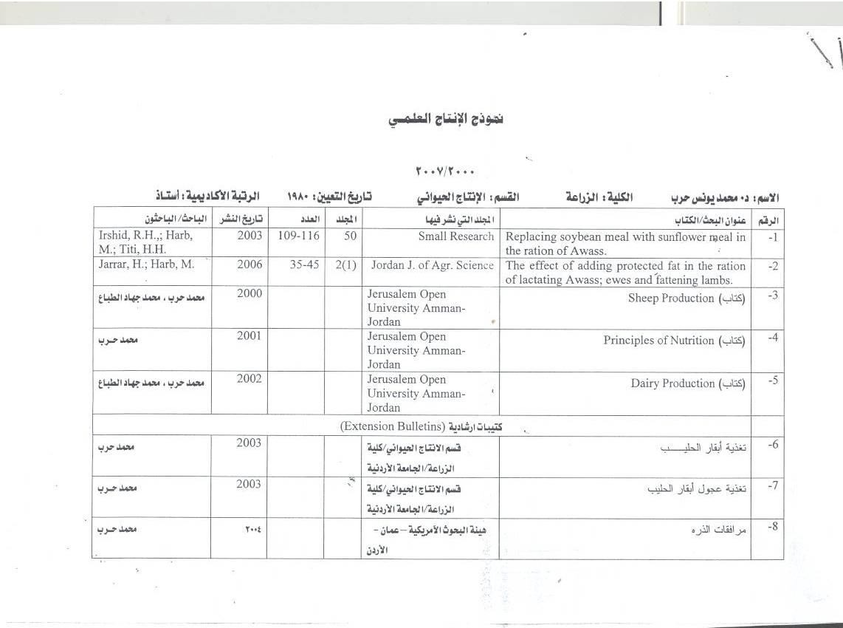

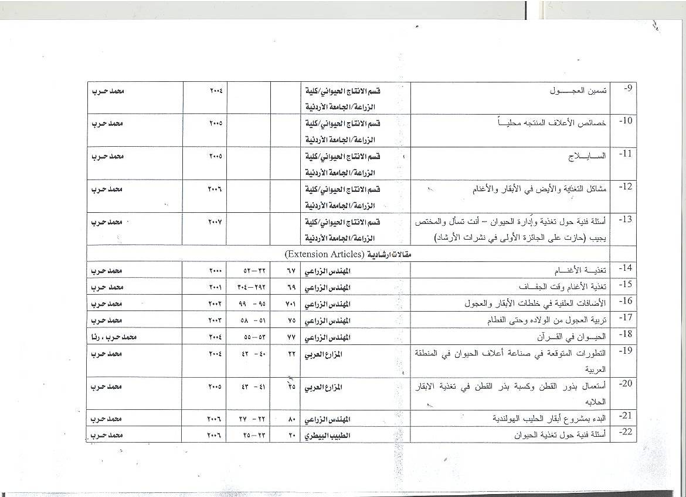

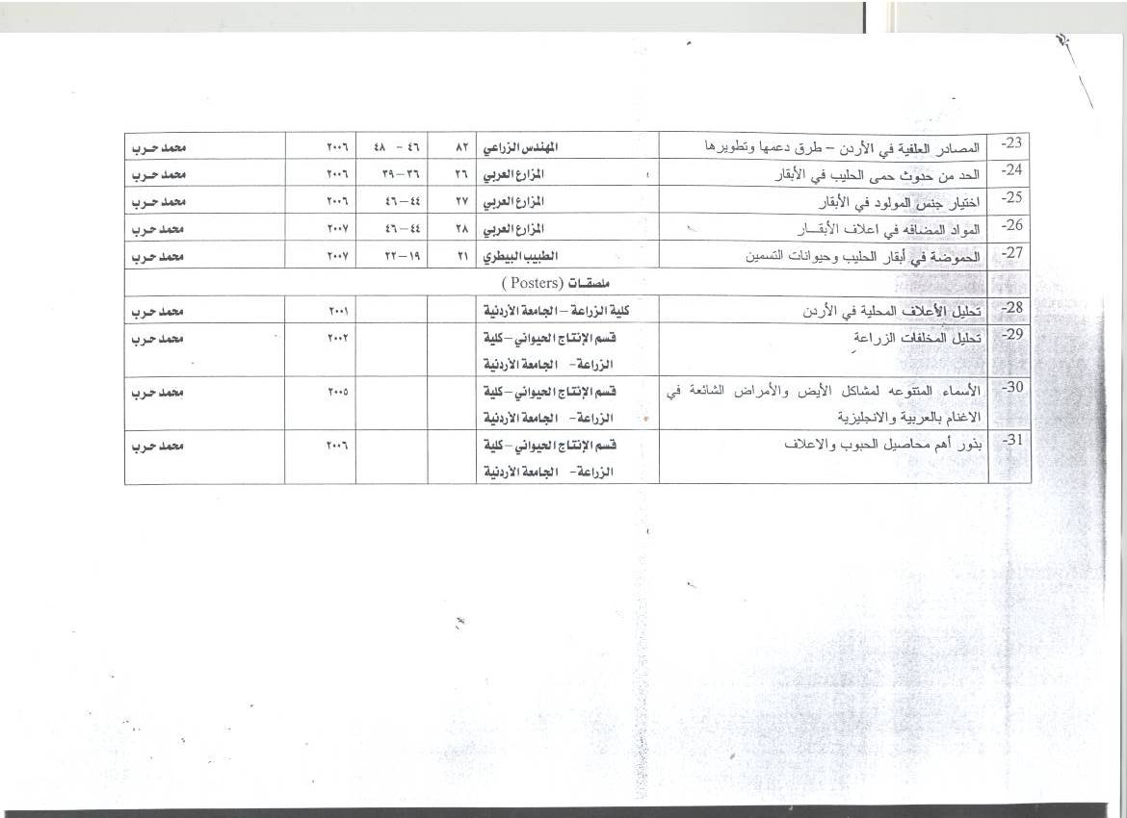
Membership:

- Member of “British Society of Animal Production”.
- Member in “Dirasat”.
- Member in “Hoards Dairyman”.

LANGUAGES:

- Arabic: Mother Tongue
- English: Excellent

October, 23rd2002.
Signature of Staff member Date:

